

Last Kilometre Freight - Breakfast Workshop

Friday 27 March 2015
A Connected City
We manage movement in and around our growing city to help people trade, meet, participate and move about safely and easily, enabling our community to access all the services and opportunities the municipality offers.
Contents
Last Kilometre Freight - Breakfast Workshop 1
Contents 2
Introduction 3
Workshop intent 3
Workshop overview 3
Presentations and Questions 5
Presentations 5
Question and answer sessions 5
Workshop Session 7
Brainstorm 7
Themes 7
Headlines 7
Businesses working together 9
Street Access 10
Timing and ‘spreading the load’ 11
Project Infrastructure 12
Building and street design 13
Vehicle types 14
Next Steps 15
Workshop Presentations 16
Presentation One: City of Melbourne 16
Presentation Two: Rose McArthur Mott MacDonald 19
Presentation three - Bestrane 26

Disclaimer
This report is provided for information and it does not purport to be complete. While care has been taken to ensure the content in the report is accurate, we cannot guarantee is without flaw of any kind. There may be errors and omissions or it may not be wholly appropriate for your particular purposes. In addition, the publication is a snapshot in time based on historic information which is liable to change. The City of Melbourne accepts no responsibility and disclaims all liability for any error, loss or other consequence which may arise from you relying on any information contained in this report.
To find out how you can participate in the decision-making process for City of Melbourne’s current and future initiatives, visit Participate Melbourne.

Introduction

Workshop intent
A stakeholder engagement workshop on last kilometre freight was held on Friday 27 March from 7 am to 9:30 am at the Melbourne Town Hall.
The purpose of the workshop was to understand the community’s issues and opportunities with central city deliveries and to raise awareness of how last kilometre freight operations may be impacted by growth and change in the central city.
The workshop allowed attendees to ask questions and explain their key challenges, needs and ideas to the City of Melbourne - feedback which will be considered as we draft the Last Kilometre Freight Plan.
The workshop was facilitated by Bruce Turner from Phoenix Facilitation.

Workshop overview
Mr Turner briefly explained how the workshop would run and introduced the Deputy Lord Mayor who welcomed attendees and explained the City of Melbourne’s interest in last kilometre freight.
The workshop was in two parts, presentations and workshop.

Presentations

Presentations were given by:
- David Mayes - Manager Strategic Planning, City of Melbourne.
- Rose McArthur - Technical Director, Integrated Transport Division, Mott MacDonald.
- David Sanders and Scott Hancock - Group Managing Director and Director of Technology, Bestrane.
Mr Mayes presented on the City of Melbourne’s interest in last kilometer freight and introduced attendees to the project. International guest, Rose McArthur, then followed with a presentation on her experiences working on travel demand and last kilometre freight management projects using the London 2012 Olympics and the Glasgow 2014 Commonwealth games as examples. Ms McArthur then responded to 15 minutes of questions from the floor.
Mr Sanders and Mr Hancock from Bestrane presented on the loading dock technology their company has developed, which is currently being used by the Emporium shopping centre in Melbourne’s CBD and the Barangaroo redevelopment in Sydney. Question and answer time also followed Bestrane’s presentation.

Workshop
The second part of the workshop was a roaming brainstorming task where attendees were invited to identify what is working well, ideas, issues and aspirations for central city deliveries on post-it notes. These were then posted to the appropriate poster boards stationed around the room. Each poster covered a key last kilometre freight topic.
Attendees were then invited to gather around a board of interest to help group similar issues. A representative for each board then reported on the ‘headlines’.

Workshop close
Mr Mayes thanked attendees for their participation, outlined the next steps for the City of Melbourne and closed the workshop. Attendees were welcome to remain and continue discussions with the presenters and other attendees.

Agenda

Last Kilometre Freight – Breakfast Workshop
Date: 27 March 2015
Time: 7:10am to 9:30am
Where: The Yarra Room, Melbourne Town Hall
Item | Start | Time | Who
Breakfast buffet opens | 7:10 | 25 | N/A
Welcome – Deputy Lord Mayor | 7:35 | 5 | Deputy Lord Mayor Susan Riley
City of Melbourne presentation and project introduction | 7:40 | 5 | David Mayes
Presentation by Rose McArthur | 7:45 | 15 | Rose McArthur
Q&A with Rose McArthur | 8:00 | 10 | Rose McArthur
Presentation by Bestrane | 8:10 | 10 | David Sanders & Scott Hancock
Q&A with Bestrane | 8:20 | 10 | David Sanders & Scott Hancock
Workshop  - Roaming brainstorm – now and the future  - Table discussion – group into themes  - Table report back to the headlines | 8:30 | 55 | Facilitator

Presentations and Questions

Presentations
The slides from the three presentations are included at the end of this report.

Question and answer sessions
The following questions and answers are not verbatim accounts; rather they are notes on the points raised during the question and answer sessions. Some additional information has been added for clarity.

Q&A with Rose McArthur
Q1. We used to have a lot of deliveries by rail and people would come and collect packages from train stations. Every train had a goods carriage and every station had a place for collection. Now we have gotten rid of metropolitan train deliveries. Are there any best practice examples of rail deliveries happening in other cities today?
A1: There are tube stations in London with click and collect grocery lockers so that people can get off the tube and pick up their shopping. Instead of multiple drop off points, the vans have one and people collect from there.
Over 95 per cent of freight in London is delivered on road. Rail is more for heavy goods movement.
During the London Olympics they used barges on the canal system for some rubbish collections to keep the waste trucks off the road. In terms of using rail, it was discussed but it never really got off the ground. It would have been difficult to collect from urban rail stations at a bigger scale.
Q2. I like the idea of a freight journey planner. Is that something that was in place before the games?
A2: The journey planner was probably the most singularly effective tool. It was one of the key milestones in getting the freight community on board because all of a sudden they had a realistic understanding of what things looked like for them. It included height and width restrictions as well as congestion on the street. The planner helped people understand what their journey time really would be so that they could use this as the basis to make an informed decision about how and where they moved.
Q3. Could the tram network be used to make deliveries in Melbourne? I know Australia Post officers use them to deliver their letters.
A3: If you think about the volume of people trying to use public transport in European countries - public transport is a finite resource within cities and using trams for deliveries is not a good use of this resource given increasing demand for tram services from the population. If you look at Rotterdam and Amsterdam - they are delivering a lot of things by bicycle. The use of the public transport system in Europe for deliveries is not a good use of the resource, except for overnight.
Q4. The literature on this topic is about getting partnerships together and talking and talking. Please comment on this. Also, going back to the freight planner and how you got the companies to come on board - you said it was a long process.
A4: It took 12 months to get three organisations aligned and supporting the messages (for freight management for the London Olympics); reduce, retime, remode, use a bike. Everyone has a different agenda and opinion.
How to get those people aligned is challenging. Urgency usually gets the better of people but it is all about leadership. In London it was Peter Hendy, Commissioner for Transport for London, who took charge and got things organised. He led the freight bulletin and the bulletin is still in use today. During the London Olympics Transport for London received its highest ever satisfaction scores from the public and companies – communication was a key reason for this.
Leadership is key, as is selling it right - that internal stakeholder engagement. There is a freight team still in place in London which was there during the Olympics.
Q5. Can you give some examples of where micro distribution centres have been used?
A5: It is always the organisations that put micro distribution centres in place. They know their businesses and their needs. We helped them by facilitating with information and support. These micro distribution centres were used by people who were innovative.
It is everyone doing one little thing – not one person doing everything.

Q&A with Bestrane
Q1. A lot of companies don’t want other companies knowing what they are doing. Is there an issue with information sharing and organisations not wanting to share and how do you overcome that?
A1: That’s true - whilst there is a community of vendors that surround each centre, those companies will compete in other contexts. The design of each community of interest needs to take this into account.
In each community we understand which carrier is contracted to deliver to each retailer. This combined with the sophisticated security model ensures that this information is only shared with parties authorised to do so.
The carriers don’t see what the other carriers are doing and the retailers don’t see what other retailers are doing, they don’t even know if their goods came on the same truck.
It is this model that permits 95 per cent of the bookings to be made on an automated basis.
Q2. Do you manage to do pick-ups with your system?
A2: A Dock Appointment is a promise to be at a certain place at a certain time – be that to pick up or deliver. These appointments can also be integrated with Purchase Orders or Sales Orders.
Q3. Is there any scope for this (Bestrane’s freight booking system) to eventually be applied to a whole city?
A3: Absolutely. For example Barangaroo South is a mini city with a wide ranging community including residential, commercial, retail and entertainment. Its first residents move in later this year. When fully occupied it will have a working day population of around 30,000. This community will need to share a common set of loading docks to be controlled by MobileDOCK.

Workshop Session

Brainstorm
The second part of the workshop involved a roaming brainstorming session where attendees identified what is working well, ideas, issues and aspirations for central city deliveries on post-it notes and then posted these to corresponding poster boards. Each poster covered a last kilometre freight topic.
The topics were as follows:
- Businesses working together - cooperation, coordination and consolidation
- Street access - parking facilities, loading zones and the use of space
- Timing and spreading the load - timing of deliveries, way-finding, scheduling and technology
- Project infrastructure - planning for disruptions, construction and events
- Buildings and street design - physical design and layout of streets and buildings
- Vehicle types - vehicle impact, mode options and technological advances.
Each poster was divided into four sections:
- What is working?
- Current issues
- Aspirations
- How to get there?

Themes
Attendees were then invited to gather around a board of interest to group together similar issues.
The following six pages contain verbatim write ups of each board, including layout. Each dot point represents an individual post-it note and each capitalised heading is the category name given in the grouping activity.

Headlines
A representative for each poster then reported back on the ‘key headlines’ from their board.
The key headlines, as reported to the group, were:

Businesses working together
- fragmentation today - lack of direction from government as to what their role should be
- IP sharing is an issue, businesses are anxious about sharing
- ideas on hubs, lockable boxes like Australia Post have and consolidation centres
- using current infrastructure differently
- collaboration - Australia Post owns last kilometre deliveries to the home, potential to use some of their learnings

Street access
- ticketing systems like Sydney
- lowering speed limits in the CBD
- lots of bicycle talk
- theme of where loading zones should be placed – street corners, consolidated, extended clearway hours, etc.

Timing and spreading the load
- enthusiasm for local trials
- after-hours deliveries as key opportunities but need to work with industry
- desire for more information

Project infrastructure
- events are individually well managed
- information silos is an issue – data exists but it is hard to get hold of
- thinking of Melbourne as in a state of permanently hosting an event
- Melbourne Metro is coming
- need more open data

Buildings and street design
- consolidation centres
- integrated services for many functions
- sensors on road to manage loading zones
- prohibit private car parking

Vehicle types
- pedestrians not influenced too much at the moment
- vehicles are too large
- use bikes to connect to nodes at the edge of the city
- creating a congestion zone to keep private vehicles out

Businesses working together
Cooperation, coordination and consolidation
What’s working? | - the Olympics acted as the trigger to drive change in London. What/how can change be triggered/driven in Melbourne
Current issues | IP Sharing  - anxious about sharing info  - commercial int.  - IP  - data sharing  Fragmentation  - fragmented, lack of whole-of-chain understanding  - levels of government. Unsure what their roles could/should be
Aspirations | IP Sharing  - zone CBD for microdelivery  - adopt mobile dock or London Olympics logistics planner city-wide  - out of hours lockable boxes (in public spaces with businesses nominating preferred drops)  - aggregated, collaborate – break into precincts and have micro drop points  - independently operated CBD Hubs – accessible to all users at fringe of CBD  - consolidation centres within larger high volume (receivers) to reduce traffic  - outside the CBD freight distribution hubs and micro distribution  - micro and macro delivery hubs can be stocked overnight and customers can pick up in the morning  - use post offices and parcel lockers as business hubs to be shared by small businesses  Use existing infrastructure differently  - additional tram routes in the CBD to promote “hop-on hop-off”. Pedestrians, freight  Collaboration  - work in collaboration with entities like Australia Post who own last mile delivery to the home to provide insights for CBD implement
How do we get there? | Differentiated solutions  - different solutions for different problems (e.g. refrigerated goods)  - using technology and streams. Different solutions for all goods – e.g consumables (e.g. food, etc) versus higher value items  - deliver foods and remove waste (or other goods) in the one trip  - retailers/deliverers have a trust relationship so goods can be delivered off hours without need for retail staff to be present

Street Access
Parking facilities, loading zones and use of street space
What’s working? | Ticketing  - why ticket delivery drivers? We need businesses, they need goods. What is the point?  - tickets for loading zones (like Sydney)  - new drivers (for example small craft beer company) get ticketed for delivering at the wrong time  - competing modes for the same road space
Current issues | Limits and conflicts  - lower traffic speed in the CBD to discourage private car use  - delivery vehicles and other road users - avoiding potential conflict between pedestrians/cycle and delivery vehicles  - prioritising modes on select routes (road use hierarchy) to optimize trips for that particular mode
Aspirations | Cycles  - cargo bike storage on street parking  - use e-cargo bikes to bypass noise restrictions in evening (24 hour city)  - upgrade key cycle routes to accommodate e-cargo freight. E.g. St Kilda Road  - drop boxes on side of road for cargo bikes  - interactive website that shows delivery restrictions (info for drivers)  People movement  - super tram stops  - traffic lights 1 x lane  - ‘all peds go’ crossings  - all traffic flow
How do we get there? | - shared micro distribution centres  Congestion  - extend clearway hours  - congestion levy for CBD  Loading zones  - more loading zones on street corners. Deliveries completed in grids  - loading zone and clearway app  - loading zones on corners of street  - consolidated loading zones  - data collection on loading zone utilization  - loading zones with sensors to book/fine couriers

Timing and ‘spreading the load’
Timing of deliveries, wayfinding, scheduling and technology
What’s working? | Info  - journey planner (London experience)  - GPS and route planning  - easy info for new deliverers  - seek better co-ordination between suppliers so trucks do not run empty  - templates and guides on what to do  - wayfinding signage not good regarding loading zones and regular parking
Current issues | After hours  - B2C more comfortable with after hours. B2B problems with cost for carriers and receivers  - after hours delivery costs for labour and higher level of management of fatigue  - night under utilised  Research  - what is the CDB’s freight task and how is it special?  - deliverer’s perspective: do they have to deliver after-hours in CBD and work-hours elsewhere on their run?
Aspirations | After hours  - consolidate pick-ups and deliveries to use one vehicle instead of two  - probably biggest opportunity area  (applies to all topic areas)
How do we get there? | Local/small  - Flinders Street Station redevelopment to include small drop off/ delivery collection points. Concierge service for consumers  - rail delivery points in Melbourne. Drop off points in metro station  - start with the keen ones. Work with those keen to move fastest  - share evidence, start small, learn fast, keep it open (no “black box” proprietary solutions)  - consumer/community delivery from hubs  - pilot in Degraves Street  - localism and decentralized urban forms  - small, nimble decentralised delivery models  - shopping strips can have a container to which goods are delivered off hours - better coordination between retailers  - get the precincts lockers. Precincts to sort it out  - experiential retail. Distribution at the fringe and deliveries  - mass customisation. 3D body scanning. Customised fit and production

Project Infrastructure
Planning for disruptions, construction and events
What’s working? | - dis/con events individually well managed
Current issues | - access to siloed data  - company/private data  - data exists in silos  - event dates/info  - road closures  - road works  - pedestrian counts  - parking data
Aspirations | - Melbourne Metro rail project - don’t waste a good crisis  - think of and plan for the City of Melbourne as a “permanent event”  - more open data  - machine readable  - private and public  - sophisticated markets for data
How do we get there? | - parking stations outside of CBD fringe  - explore ways for balancing privacy with “public good”  - don’t just focus on the CBD  - Arden Macaulay  - City North  - freight forum and regular weekly bulletin  - more communication  - coordinated  - on advice from precincts  - what do they want?  - shared consolidation centres in CBD

Building and street design
Physical design and layout of streets and buildings
What’s working? | Quiet delivery docks  - quiet delivery docks built into planning scheme rather than retrofitted  - encourage/support innovation for quiet delivery docks  Early planning  - think about how freight will be impacted in planning stage  - planning support for more secure deliveries  - deliveries pelletised. Freight through tailgate - no dock space  Safety/environment  - safety for visitors/pedestrians from loading zone uses  - street environment - how can we reduce the impact of loading docks on the street and amenity  - how to get tradies out of loading zones and Swanston Street  - urban renewal and change precincts - how can we integrate services for many buildings and functions
Aspirations | Regulations  - mandate maximum loading bay areas  - use of roads/streets for dedicated loading zones times - bookable  Building design  - land use ‘conflict’ - in an increasingly mixed use city - how can building design help prevent conflicts? e.g. noise, light spill, etc.  - mandatory parcel lockers fore CBD buildings  - consolidated freight dock in apartments  - use ground floor of big city carparks for service vehicles; mini freight hubs
How do we get there? | Technology  - sensors in road to manage loading zone booking times  - prohibit private car parks on certain streets to free space for other purposes  - Swanston Street loading zones - sensor bookable  Parking for alternative vehicles  - influx of motor scooters - create onroad parking bays for loading scooters  - remove large loading zones from high pedestrian/high tourist roads  - use end of Bourke Street Mall (between Swanston and Russell streets) as parking then deliver on trolley  - remove all street public parking during business hours to be used by commercial/freight vehicles

Vehicle types
Vehicle impact, mode options and technological advance
What’s working? | - the pedestrian experience in Melbourne doesn’t seem heavily impacted by freight  - delivery vehicles too large
Current issues | - very limited use of low impact modes  - vehicle emission problems
Aspirations | Electric/hybrid vehicles  - more cargo bikes meeting  - electric delivery vehicles  - electric cargo bike  - electric cargo bikes  - hybrid technology - engine stop not idle  - encourage use of electric delivery vehicles  - smart vehicles - energy, capacity, fit for purpose  - collaboration between quiet electric vehicle manufacturers and businesses  Bikes  - cycling as a freight mode  - use of cargo bikes for smaller speedier deliveries  - cargo bikes meeting vans on skirt of CBD  - cargo bikes share scheme - ‘Go Get’ for cargo bikes  - provide incentives for cargo bikes  Off peak activity  - right vehicle for night task e.g. utilisation/productivity of individual vehicles maximised  Off peak rail/tram  - use off-peak rail as per former goods carriage  - off-peak freight trams
How do we get there? | Alternative networks  - use the river  ‘Congestion’ zone  - removing not required vehicles (private) from the CBD

Next Steps
Following the pre-draft community engagement on issues and opportunities, the next step is to draft a Last Kilometre Freight Plan for the City of Melbourne.
The feedback and learning’s derived from this workshop will help to inform the draft plan.
The draft plan will be presented to the City of Melbourne’s Future Melbourne Committee for consideration later this year, if the draft plan is endorsed by the Committee, community engagement on the draft will be undertaken giving our community a further opportunity for input into the project before a final plan is prepared and endorsement from Melbourne City Councillors is sought.
Last Kilometre Freight Timeline
Stage 1 – Project initiation
Stage 2 –Case Studies Report, Issues and Opportunities Report, Background Report
Stage 3 –Engagement (we are here)
Stage 4 – Draft Last Kilometre Freight Plan
Stage 5 – Draft Plan Engagement
Stage 6 – Final Last Kilometre Freight Plan

Workshop Presentations

Presentation One: City of Melbourne
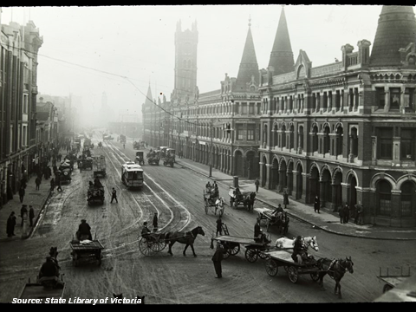
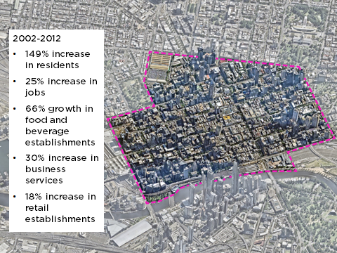
Between 2002 and 2012 there has been a 149 percent increase in residents, 25 per cent increase in jobs, 66 per cent increase in food and beverage establishments, 30 per cent increase in business services, 18 per cent increase in retail establishments.
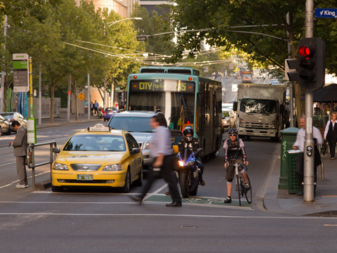
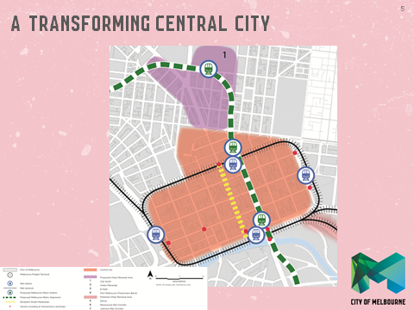
The above map of Melbourne shows:
- City North Urban Renewal Area, bounded by Victoria Street, Swanston Street, University of Melbourne, Story Street, Harcourt Street, Courtney Street and Capel Street.
- Central city, bounded by Flinders Street, Spring Street, Victoria Street, Peel Street, William Street, La Trobe Street and Spencer Street.
- City Loop train line, with stations at Southern Cross, Flinders Street, Parliament and Melbourne Central.
- Proposed railway line from the north, with a station at Parkville, travelling south along Swanston Street with stations near Melbourne Central and Flinders Street.
- Works along Elizabeth Street as part of the Elizabeth Street Master Plan.

Purpose of the workshop
- Bring people together to stimulate thinking on how a transforming central city will change the way goods are delivered.
- To hear what are the big issues and opportunities in last kilometre freight.
- To learn from overseas examples and from each other to improve the way we deliver and receive goods.
- To begin the conversation on better freight solutions for the central city.

Questions
From your experience NOW:
- What is working well?
- What are the current issues?
Thinking about the FUTURE:
- What are your aspirations for the central city?
- How do we get there?
  - What can you do?
  - What should the City of Melbourne do?
  - What else should be done? Who should do it?

Submissions
- Completing the feedback forms on your table
- Online at Participate Melbourne
- By email to freight@melbourne.vic.gov.au

Next steps
Stage 1 – Project initiation
Stage 2 –Case Studies Report, Issues and Opportunities Report, Background Report
Stage 3 –Engagement (we are here)
Stage 4 – Draft Last Kilometre Freight Plan
Stage 5 – Draft Plan Engagement
Stage 6 – Final Last Kilometre Freight Plan

Presentation Two: Rose McArthur Mott MacDonald
How to Keep City Freight Moving During Planned Disruption, Travel Planning Comes of Age
- Manage expectations – so that reasonable passenger and business expectations are set (i.e. plan your journey in advance, expect some delays, works will be happening for 2 years etc.)
- Manage total demand at hotspots – Reduce, retime, remode, reroute
- Help optimise the transport network – by providing all users with guidance on the most appropriate routes available (including non-intuitive)
- Work closely with the business community – to minimise demand whilst ensuring continuity
- Support transport reputation management – all of you
- Provide legacy foundations – for long-term positive behaviour change
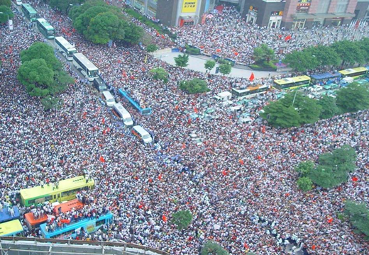
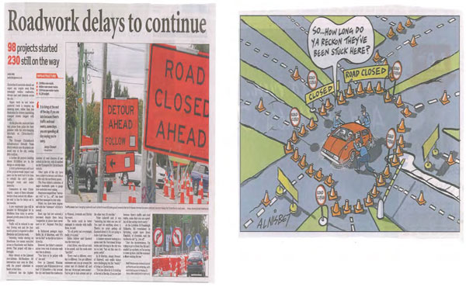

TDM Interventions & Audience Segmentation
The TDM Programme:
Travel Advice for Businesses | Working with business & intermediaries  Sliding scale of support  Targeted self-help material  Travel advice campaign site
Freight | Engagement with the Industry  Change to delivery patterns  Web toolkit & Focus group  Awareness Campaign
TDM Communications | National & Gold Coast Awareness Campaign  Business Focus Campaign  Hotspots Campaign  GRN, Venues & Hotspots Campaign
Travel Advice Services (TAS) | Games Travel Web pages  Spectator Journey Planner  Real Time Travel Information  Mapping/guides/handouts

London 2012 – Understanding the Challenges
Freight
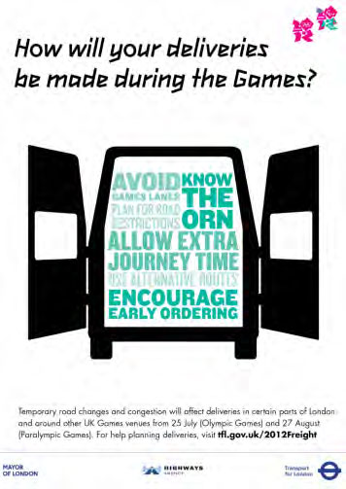

Implications – Deliveries
- Longer delivery journeys
  - Impact on drivers hours
- Reliability in meeting delivery windows
- Kerbside access
- Proximity to venues and local access
- Road events – timings and access to premises

Solutions
- Reduce - pre-order, preventative maintenance
- Re-time - out-of-hours deliveries, change days
- Re-route - change drop order
- Revise mode - collect from store, deliveries to staff
One size doesn’t fit all:
- Depends on location / sector / commodity
Communicate with your supply chain
- How are your suppliers preparing?
- Have they attended freight advice workshops?

Out-of-hours delivery
Current advice to businesses and operators
- Identify delivery points impacted by Games-time changes to network
- Understand nature of restrictions that impact each delivery point (planning, noise, alcohol licensing, kerbside, voluntary, or none)
- Determine appropriate solutions to the delivery issues identified (e.g. pre-ordering or consolidation of activity, rather than an out-of-hours delivery)
- If there are no restrictions, or they are voluntary – operators and businesses should use the Code of Practice, taking into account the local situation
- If other restrictions apply - businesses should talk to the Borough
- Guidance note from Local City Council

Out-of-hours delivery – Westminster
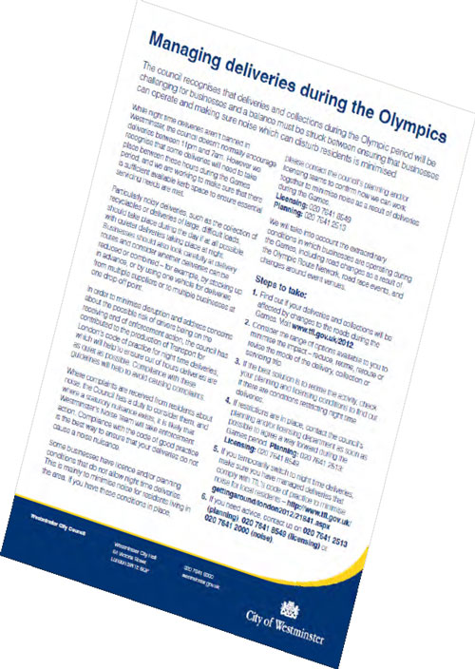

Freight Journey Planner
- Plan journeys taking account of all Olympic restrictions
- Free to use
- Bespoke routes for different vehicle sizes
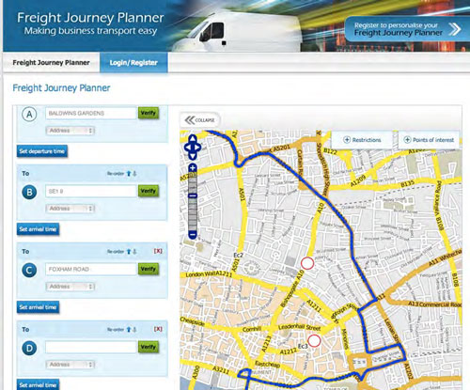

Summary
- Plan
  - 4 Rs
  - Understand your particular circumstances
    - Location
- Speak with your supply chain

Business and Freight engagement
- 150 business intermediaries supported
- Major businesses directly participating in 611,000 employees (600 SSA)
- 20,000 SMEs in hotspots visited by TDM representatives
- 42,000 packages of information mailed to London businesses
- 1,025,115 business newsletters sent during the Games
- 21,786 businesses attended presentations
- 2,856 businesses given direct freight advice
- 3,013 people attended freight workshops
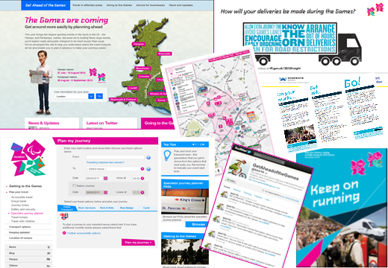

What happened?
- A third of Londoners did something different during the Games
- Olympic Games weekday behaviour changed 35%
- Paralympic Games weekday behaviour changed 31%
- Re-time the favourite of the 4Rs – followed closely by the reduce
- 15% less traffic in central and inner London on highways
- Record patronage: 62 million tube journeys, 35% increase: 4.5 million on the busiest day on the tube
- No meltdown

Legacy
- OOH deliveries continue
- Freight Forum continues
- Communication as much as transport planning
- Every program refines and develops the solutions
- Collaboration is absolutely key
- Using every single lesson learned really helps


Presentation three - Bestrane

MobileDOCK Leadership
David Sanders, Founder – Bestrane Group
CEO since founding Bestrane. Formerly Managing Partner at Dawson Consulting, Supply Chain Practice Leader for Deloitte Consulting and A. T. Kearney.
Scott Hancock, CTO – Bestrane Group
Chief Technology Architect. Formerly Oracle, Descartes and Dunn and Bradstreet.
Bestrane was created to develop technology enabled Supply Chain Co’s.
MobileDOCK is 100% owned by Bestrane Group and completely focused on enabling Smart Cities

Optimal, Secure Dock Delivery is enabled by:
- Eliminating Road Congestion
- Eliminating Site Congestion
- Minimising Wait Time
- Reducing Greenhouse Gas Emissions
- Increasing Site Capacity
- Increasing Delivery Efficiency
- Providing Compliance Management

The Dock Delivery problem
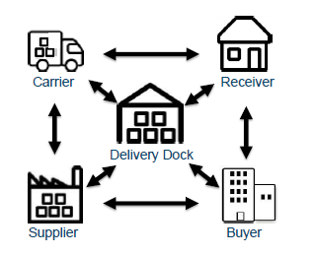

Issues
- Manual Processes
- Unscheduled Arrivals
- Unannounced Arrivals
- Incompatible Vehicles
- No auditable POD
- Inefficient Labour
- Limited Visibility
- No Chain of Responsibility

Consequences
- Traffic Congestion
- Dock Utilisation
- Wait time
- Unidentified Delivery
- No Accountability
- Lost Revenue
- Uncertainty
- Liability

Current Business Practice
Inefficient and High Cost, High Risk
- Manual planning
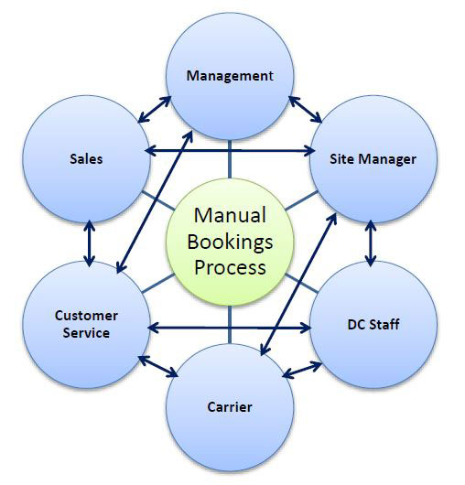
- Manual execution
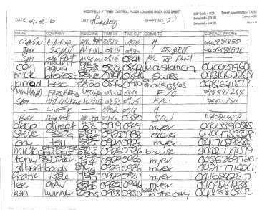

The MobileDOCK Transaction
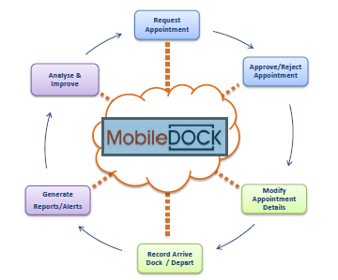

MobileDOCK connects a community
Emporium Melbourne – 4000 Appointments per Month
- 650 carriers
- 380 suppliers
- 364 receivers (tenants)
- 250 buyers

Communities are Cities
Barangaroo – 000’s Appointments per Month
- 00’s carriers
- 000’s suppliers
- receiver – commercial, retail, residential, place, construction
- 00’s Buyers

Traffic swarms
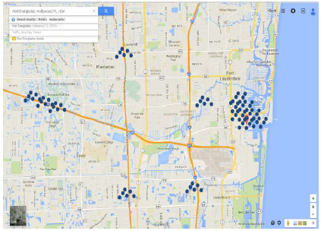

Swarms to ant trails
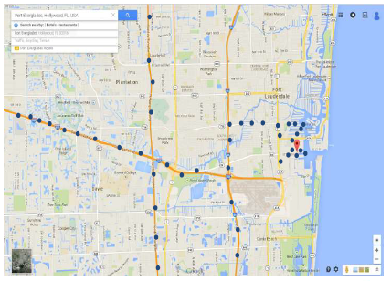

Results
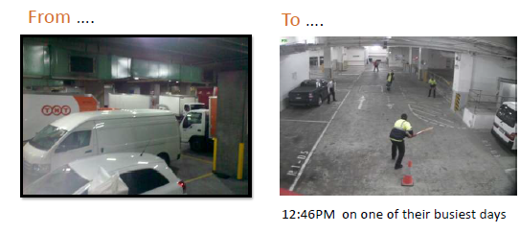

Community Results…
Carriers
- Know that they can get in and out efficiently … if they have an appointment
- Know that they will not get in if they do not have an appointment
- Added capacity of approximately 1 hour per day to each route
City Precinct
- Reduced congestion … no queues
- Reduced pollution …. Reduced CBD idle time
- Increased Amenity
Retailers / Receivers
- Advanced knowledge of what is being delivered when … enhanced stock control
- Certainty of stock arrival time …enhanced labour management
- Increased supply chain security … shortages identified on arrival

The MobileDOCK Transaction
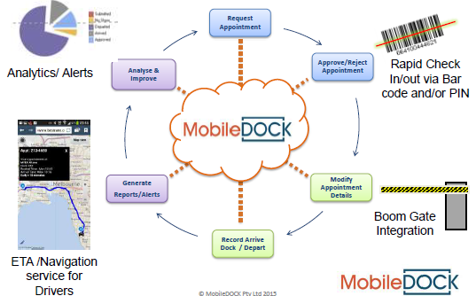

MobileDOCK is proven and ready
- 95% bookings are made and managed automatically
- 10,000+ community participants
- Network effect
- 100% retention
- Scalable to large communities
- > 30,000 transactions/mth
  - Barangaroo, Sydney CBD Precinct
  - Westfield, Sydney (450 Retailers)
  - Westfield, Bondi (520 Retailers)
  - Westfield, Miranda (450 Retailers)
  - Westfield, Chatswood (350 Retailers)
  - Emporium Melbourne, 350 Retailers
  - OneSteel, 8 Distribution Centres
  - Super Retail Group, 3 Distribution Centres
  - Snack Brands, 3 Distribution Centres
  - Myer, 4 Distribution Centres.

http://www.melbourne.vic.gov.au/participate

