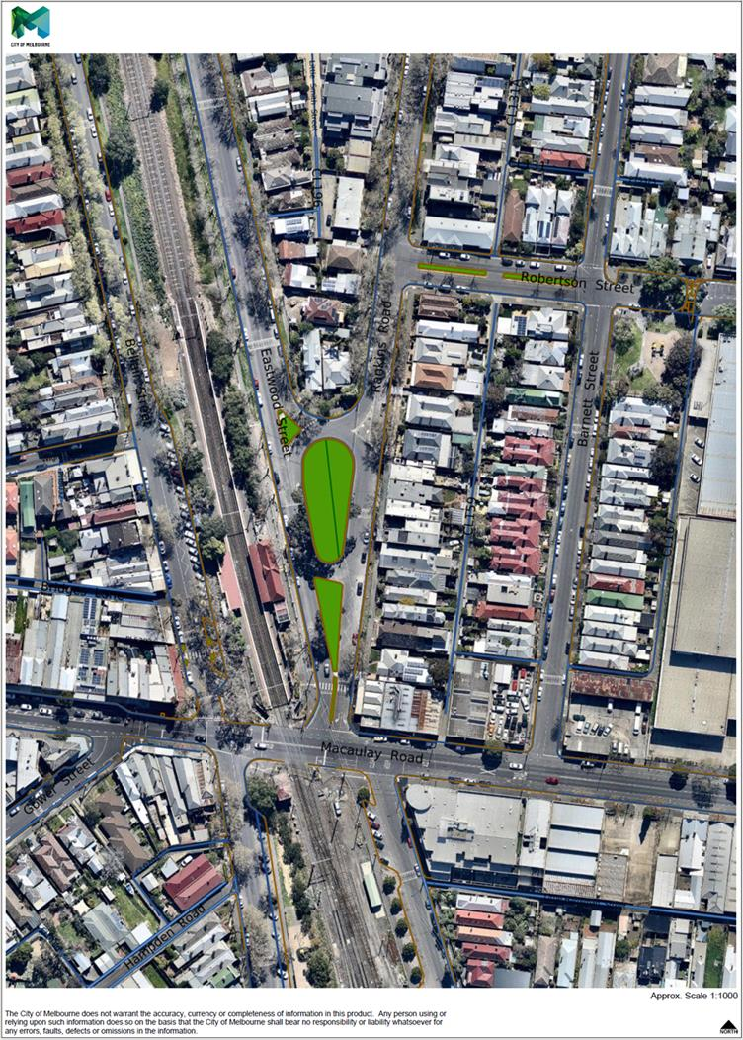

**Traffic Data Summary and Location of Traffic Counters – 4 December 2014**

**(Prior to Construction of Eastwood and Rankins Road Park)**

737

50

341

533

329

281

**Total Traffic Volume at Macaulay/Rankins Intersection (24hrs), One-Off Week Day Count = 2271**

South bound traffic only (24hrs) = 1143

North bound traffic only (24hrs) = 1128

One-way Traffic Volume Week Day Average = 1041

Speed: 85th Percentile = 35

Average Speed = 29.4

Two-way Traffic Volume Week Day Average = 638

Speed: 85th Percentile = 24

Average Speed = 20.4

Two-way Traffic Volume Week Day Average = 2389

Speed: 85th Percentile = 33

Average Speed = 28.7

4



149

99

161

185

**Total Traffic Volume at Macaulay/Barnett Intersection (24hrs), One-Off Week Day Count = 455**

South bound traffic only (24hrs) = 207

North bound traffic only (24hrs) = 248